**Ray Wiltsey**

**PBIS**

**Handbook**

**2022-2023**

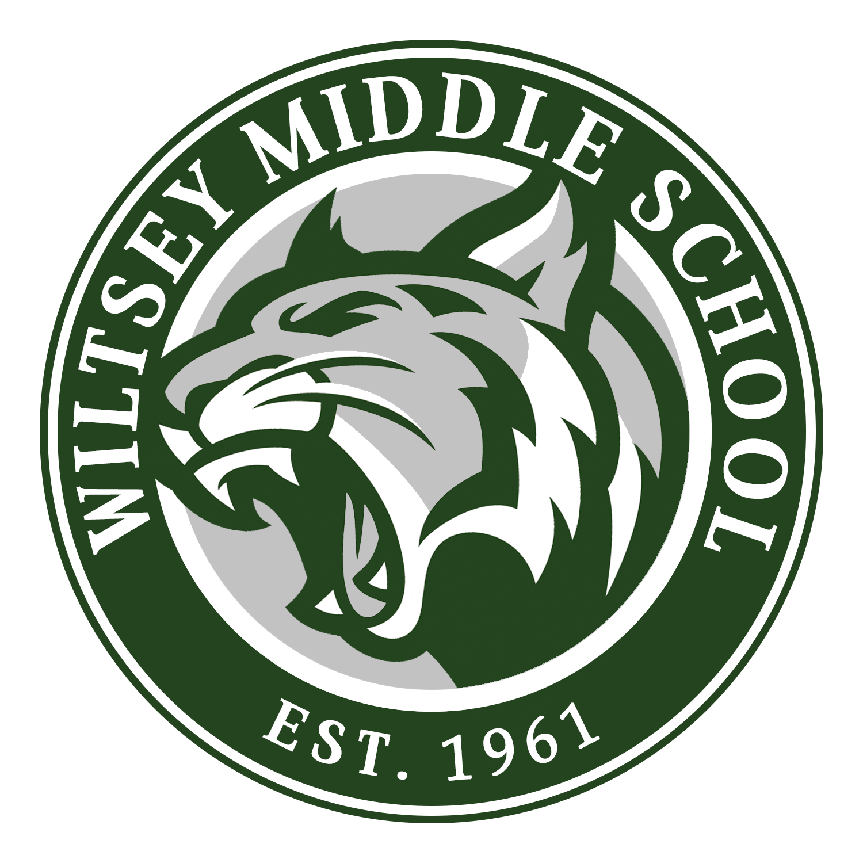

**Wildcat Philosophy**

This program is our school-wide discipline plan. It is based on PBIS (Positive Behavior Interventions and Supports) and rewards students for demonstrating expected behaviors.

The Model Wildcat plan encompasses documentation at all levels, as well as responsibility for all students, staff, and families. We will follow four basic school-wide expectations:

Be Safe, Be Respectful, Be Responsible, and Be Ready to Learn.

All students will follow the Wildcat Pledge.

**Wildcat Pledge**

**Ray Wiltsey Wildcats are a**

**community of learners who are**

**respectful of self and others,**

**responsible for our behavior**

**and academic achievement,**

**safe at all times,**

**and always ready to learn**



**Wiltsey Middle School Expectations**

**Be a Proud Wildcat**

|  |  |  |  |  |  |  |  |
| --- | --- | --- | --- | --- | --- | --- | --- |
|  | **OFFICE** | **CLASSROOM** | **LUNCH AREAS** | **MPR** | **RESTROOM** | **HALLWAY** | **LIBRARY** |
| **BE SAFE** | *Be aware of others’ personal space  *Enter and exit in an orderly manner  *Keep hand, feet, and other objects to yourself | *Enter & exit in an orderly & quiet manner  *Keep hands, feet, and objects to self  *Report any safety issues to an adult | *Keep a safe distance while waiting in line  *Keep food on tray  *Keep all food off the ground | *Keep a safe distance while waiting in line  *Keep food on tray  *Keep all food off the ground | *Walk to and from restroom  *Keep water off the floor  *Report problems | *Walk at all times  *Keep hands, feet, and objects to yourself  *Remain in supervised areas | * Keep hands, feet, and objects to yourself  *Enter and exit in an orderly and quiet manner  *Walk calmly |
| **BE**  **RESPONSIBLE** | *State your purpose politely  *Wait patiently  *Return to class promptly | *Be on time with all necessary materials  *Be actively engaged during instruction  *Complete all classwork and homework | *Report directly to lunch line  *All food & drink stays in lunch areas  *Clean up your area & place trash in proper bin | *Wait your turn in line  *All food & drink stays in lunch areas  *Clean up your area & place trash in proper bin | *Flush toilets  *Wash your hands  *Put trash in trash cans  *Sign in and Out | *Walk with purpose  *Be in your next class before the bell rings  *Put trash in the trash can | *Leave library clean and push in all chairs  *Keep books off the floor; return books to proper places  *Read quietly |
| **BE RESPECTFUL** | *Use polite language “please” and “thank you”  *Wait your turn to speak to an adult  *Use appropriate voice, tone, and volume | *Follow all adult directives and respect educational rights of others  *Treat others kindly  *Take care of personal and school property | * Keep hands off of other’s food  *Use manners and polite language  *Listen to all adults | * Keep hands off of other’s food  *Use manners and polite language  *Listen to all adults | *Give people privacy  *Wait your turn  *Use appropriate voice, tone, and volume | *Use appropriate voice, tone, and volume)  *STOP, LOOK, & LISTEN when spoken to by adults | *Use appropriate voice, tone, and volume  *Listen to instructions  *Line up and wait patiently to check out books  *Return books to proper places |
| **BE READY TO LEARN** | *Be attentive to instructions from office staff | *Be prepared for learning  *Actively participate in class | *Be attentive to learn food and nutrition facts | *Be attentive to learn food and nutrition facts | *Utilize restroom efficiently to maximize classroom time | *Have an open mind  *Keep a growth mindset | *Be attentive to lessons from the librarian |

**What are PBIS REWARDS Points?**

PBIS REWARDS Points will be used to reinforce positive choices. They are a quick and easy way to recognize students who are being safe, respectful, responsible, and ready to learn. PBIS REWARDS Points will be given out digitally through PBIS Rewards.

**Who can give PBIS REWARDS Points?**

Any staff member or volunteer may give a PBIS Reward Points to any student or small group of students.

**How can a student earn PBIS REWARDS Points?**

PBIS REWARDS Points may be used to reinforce students displaying safe, respectful, responsible, and ready to learn choices. Some ideas are: reward the first row that is being respectful and quiet in class, a group of students who are walking safely through the walkways, the students who are being responsible by being in their seats and ready to work when the bell rings, etc. The possibilities are unlimited!

**What does a student do with PBIS REWARDS Points?**

Students save their points to be redeemed at our PAWS Center PBIS Store or in their individual teacher’s PBIS Store.

**What is Top Wildcat?**

Ray Wiltsey Middle School is looking for a student who goes the extra mile to demonstrate responsibility, respectfulness, and safety. This student makes Wiltsey a pleasant place for everyone. Teachers are asked to nominate one student per month for recognition as Top Wildcat. Nomination forms will be submitted via Google Forms. One student from each grade level will be selected and recognized.

**How will the Top Wildcat be recognized?**

The Top Wildcat winners will have their names read during the morning announcements. They will receive lunch with administration and a certificate.

**Positive Postcards**

Positive Postcards are sent home by classroom teachers acknowledging students who are demonstrating safe, respectful, responsible, and ready to learn behavior during the school day. The expectation is that each student will receive one postcard per quarter. Administration will determine the period selected each quarter to recognize students.

**Positive Phone Calls Home**

A positive phone call is a call that is made home by administration. Teachers fill out a form about a student who has done something that exhibits expected behavior and turns in the form to an administrator for a phone call home. A copy of the note is sent home with the student.

**What is a Minor Infraction Grid?**

This grid is set up to help staff identify and give examples of minor infractions that may occur at school. It is designed to give staff definitions of specific infractions and examples of those infractions. It also gives suggestions of how best to deal with different situations.

**How to use the Minor Infraction Grid?**

The minor infraction grid is broken into 5 stages. As the day progresses, a child might commit a minor infraction. Once an infraction has been committed, the child moves to **stage 1** of the interventions. As a teacher, it is your responsibility to use one of the interventions in **stage 1** to help the child realize the mistake. After an infraction has occurred, the teacher must log the infraction in Q. If the child commits the infraction a second time, he then moves to **stage 2**. **Make sure to document in Q each time a child moves from one stage to the next.**

|  |  |  |
| --- | --- | --- |
| **STAGE 1**  **(Choose 1)Warning** | **STAGE 2**  **(LLR)** | **STAGE 4**  **(HLR)** |
| **\*Prompts/Reminders/Pre-correction**  Provide nonverbal cues, move next to students as behavior begins, put your hand on the student’s desk/book as a reminder, provide verbal cues (say student’s name or “eyes on me.”  **\*Restate behavioral expectations**  with a verbal warning. “Respect is one of our school rules. We talk respectfully to others at Wiltsey. I don’t expect to see this behavior again.”  **\*Specifically explain WHY it is important to follow the expectations –** “It is disrespectful of other students and myself when you ___________.”  **\*Check for student understanding of the school expectations –** “Please summarize what we talked about so that I am sure there is not confusion.”  **\*Increase Praise** for appropriate behavior | **\*Have student complete a “Student Action Plan.”**  **\*Discuss with the student the possible FUNCTION of the behavior –** (ie. Gain peer attention, gain adult attention, obtain items/activities, avoid peer(s), avoid adult(s), avoid task/activity, etc.  * Phone call home  * Document in Q under Student Visits | * Document referral in PBIS Rewards  **\*Office Referral for time out**  **\*Administration handles discipline**  **\*Utilizes logical consequence** |
| **STAGE 3**  **(LLR)** | **STAGE 5**  **(HLR)** |
| *Phone call home  *Document in Q under Student Visits  *Teacher assigned consequence | **\*Teacher Suspension** – Student may only be suspended to the office for the remainder of that class plus one additional day of that class, if teacher chooses. Teacher must have documentation of the previous 4 steps. Teacher must arrange meeting with the parent.  **\*Meeting with Administration/ Parent/Teacher**  **\*Begin the SST process for behavior** |

|  |  |
| --- | --- |
| **Minor Infraction** | **Definition/Example** |
| **Inappropriate Language** | **Definition:**  Low Level instance of inappropriate language. Accidental slip of inappropriate language, poor choice of words used in common areas/classroom, non-directed verbal assault, hand gestures. Implied meaning without literal verbiage.  **Examples:**  “Shut up,” “Your Momma,” “Up yours,” profanity slips out |
| **Defiance**  **Disrespect**  **Non-compliance** | **Definition:**  Brief or low intensity failure to respond to adult request.  **Examples:**  Non responsive, off task in classroom, eye rolling, “whatever,” refusing to follow directions, ignoring, “I don’t want to,” “You’re not the boss of me,” gum chewing, talking in class, eating in class, talking back. |
|  |  |
| **Lying/Cheating** | **Definition:**  Student delivers a message that is untrue and/or deliberately violates behavior expectations.  **Examples:**  Starting rumors, copying off another student’s work, gossip |
|  |  |

|  |  |
| --- | --- |
| **Disruption** | **Definition:**  Student is disturbing other students or teacher during class time.  **Examples:**  Side conversations, note passing, tapping fingers or pencil, outburst, blurts out answer without raising hand, gets out of seat without permission, slamming books on desk, playing with things, whistling, humming, clowning around |
| **Leaving Class without Permission** | **Call Office**  **Write Referral** |
| **Out of Bounds** | **Definition:**  Going outside of assigned areas.  **Examples:**  Going in/behind/between classrooms during lunches or wandering in walkways without a pass during class time. |
| **Trash and Littering** | **Definition:**  Discarding of items or dumping of trash at any location other than trash can  **Examples:**  Dropping papers, scraps, food, etc. on floor in cafeteria, class, and/or hallway. |
| **Property Misuse** | **Definition:**  Low intensity misuse of school property  **Examples:**  Pounding on keyboard, ripping pages in a book, misusing PE equipment, touching other people’s property |
| **Physical Contact** | **Definition:**  Non-injury, inappropriate physical contact  **Examples:**  Playful contact (i.e: friendly touching, girls hitting boys and visa versa, chasing, rough housing, pushing in line, jumping ) |

**What are Major Infractions?**

Major Infractions are behaviors for which a student may need to be suspended. Administration and designees are authorized to suspend students from school. Only the principal is authorized to recommend a student for expulsion. These types of referrals are entered into the Q system and become part of a student’s permanent discipline record. Racial comments directed specifically at another person, fighting which causes physical injury, using vulgar and profane language that is beyond a slip of a word or two and directed at an adult, gang signs, stealing or damaging school property, bringing a weapon on campus, and other serious offenses which are listed on the suspension notification.

**What is a High-Level Referral?**

When a student is at stage 4 of the Minor Infraction Grid or has committed a Major Infraction, school personnel will complete a High-Level Referral. This referral provides documentation of the student’s behavior. The referral includes student name, information, name of referring adult, location of incident, identification of problem, factors leading up to the behavior, and possible function of the behavior.

**How is a High-Level Referral used?**

When a student is at stage 4 of the Minor Infraction Grid or has committed a Major Infraction, school personnel shall complete a High-Level Referral. The referral should be filled out completely. Use comments only to describe the actual events, not feelings. **No student will be seen in the office without a referral, two Low Level Referrals (LLR are documented in Q)**. If possible, call ahead to tell the office that the child is on his/her way and send the student with an escort if needed. Administration then meets with the student and enters any disciplinary actions in Q.

**Why do we need the High-Level Referral?**

This referral is documentation of students’ behavior, which must be kept. It records not only the student’s behavior, but also the school’s attempts at intervention. The environmental factors and the possible function information in the referral will help staff look for patterns and insights into the causes of behaviors. Information entered into Q, can lead to effective intervention including SARB-B referrals, SAT’s, or home visits.

**What is a Low-Level Referral?**

When a student is at stage 2 of the Minor Infraction Grid, a staff member completes a Low-Level Referral(LLR). It is documentation in Q of the student’s behavior. The Referral includes a short description of the incident.

**How is a Low-Level Referral used?**

A staff member should enter the Low-Level Referral in Q under Student Visits. The classroom teacher assigns an appropriate consequence. When a student moves to stage 3 of the Minor Infraction Grid, another Low-Level Referral is completed. When a student moves to stage 4 of the Minor Infraction Grid, the teacher completes a High-Level Referral instead of a third Low-Level Referral. Documentation must be in Q for the first 2 LLR before a HLR is entered in PBIS Rewards. The student is then sent to the office.

**Why do we need the Low-Level Referral?**

This referral is documentation of a student’s behavior which is needed to move that student up the Minor Infraction Grid. It records not only the student’s behavior, but also the school’s attempts at intervention.

**What is a Behavior Lesson?**

A behavior lesson is a 10-15 minute lesson that is taught during our extended period to the class to help directly teach students behavioral expectations.

**When should the lesson be taught?**

Each lesson is taught on the day listed on the schedule. All teachers are required to teach these lessons and hold their students accountable for the skills taught. Everyone on campus is teaching the same lesson to the students at the same time. The morning announcements will address the lesson for the day.

**Why are these lessons important?**

These lessons are important because they will teach our expected behaviors and will assist them in making safe, respectful and responsible choices.

**Behavior Tours**

Behavior tours are designed to teach students expected behaviors in the authentic environment in which they occur. Each quarter, teachers will take their entire second period class on a tour around the campus to explain behavior expectations at each sign station.

**Behavior Lesson Plans**

***These should be taught in 4th period.***

**Week One**

**August 10-12**

**Day one** Behavior Assemblies

Parent Handbook

**Day two** Wiltsey Wildcat PBIS Teacher Handbook

Behavior Tours

Time-out/ Action Plan

**Day Three** Behavior Tours

Do the following Lessons

Responsibility/Respect Social Skills I can follow direction

Safety Social Skills Keep my hands, feet and all objects to myself

Responsibility/ respect I Can Listen Attentively

**Week Two**

**August 15-19**

Responsible, Hallway, Classroom Being on Time

Middle School-Wide Social Skill I can Manage School & Personal

Property

Respect Social Skills I can Show Respect for Others

**Week Three**

**August 22-26**

Responsible, Respectful, Hallway

Responsibility, Social Skill I can Accept Responsibility for Own

Behavior

Safety-Personal Space I can Be Safe

**Week Four**

**August 29- September 2**

Responsibility I Can Stay on Task